EXPERIMENT 1
Simulation-Based Electromagnetic Analysis of TEM, TE and TM Propagation Modes in Microwave Transmission Structures
OBJECTIVE 1:
To develop electromagnetic simulation models for TEM, TE and TM propagation modes in suitable microwave transmission structures.
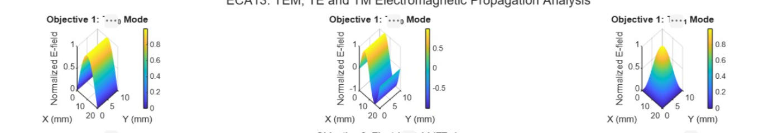
OBJECTIVE 2:
To visualize and analyze the electric-field and magnetic-field distributions associated with different propagation modes.
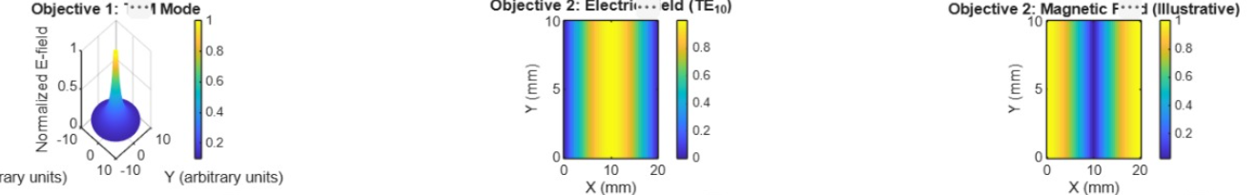
OBJECTIVE 3.
To determine the cutoff frequency, propagation constant and field characteristics of selected TE and TM modes.
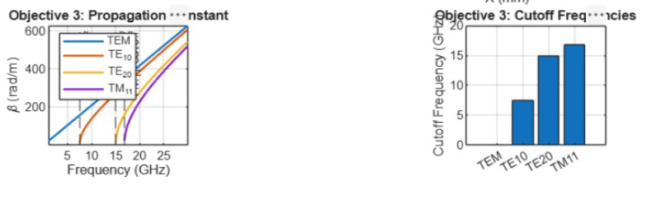
OBJECTIVE 4.
To compare the propagation behavior of different modes and identify their suitability for practical microwave transmission.
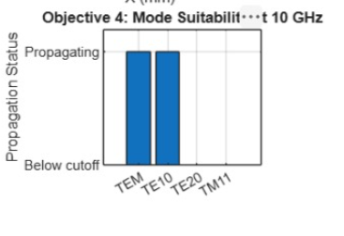
OUTPUT:
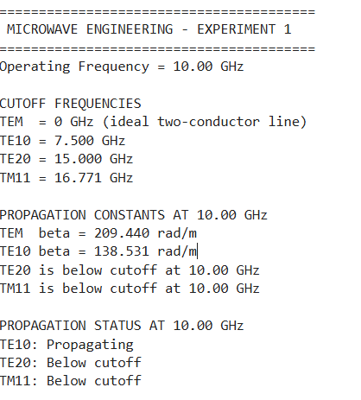
RESULT:
The MATLAB simulation demonstrates the S-parameter characteristics of a 50 Ω microwave transmission line over the 8 to 12 GHz frequency range. The plots illustrate the reflection and transmission coefficients \(S_{11}\), \(S_{21}\), \(S_{12}\), and \(S_{22}\), along with return loss, insertion loss, and transmission efficiency. The ideal matched-line model exhibits zero reflection, 0 dB insertion loss, and 100% transmission efficiency. The frequency-response analysis identifies the optimum operating frequency, while the numerical results validate the theoretical characteristics of an ideal microwave two-port network.

